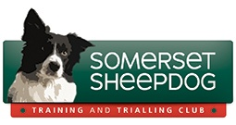

Membership Form
Name......................................................................................................................
Address..................................................................................................................
...............................................................................................................................
Telephone...............................................Mobile....................................................
Email......................................................................................................................
Fee £7.00
Acceptance of Terms & Conditions
I agree to the terms and conditions of the Somerset Sheepdog Training and Trialling Club membership. I have read the terms of the Privacy Policy and agree that my contact details can be held by SSTTC and my email address will only be circulated by Blind copy to other members of the Club and their Contact List. I consent to photos and video footage of myself and my dogs being used on the club website, social media pages and in press releases. Yes / No Signed...............................................................................Date....................
Please send completed form and payment of £7.00 per year (made payable to:- Somerset Sheepdog Training & Trialing Club) to the Membership Secretary, 38 Hayward Close, Clevedon, BS21 5ER
You might prefer to pay by Faster Transfer through your Bank.
Our details: Lloyds Bank; Sort Code: 30 91 84; Account No.23234360 + your name
Membership runs from April to April and entitles each member to run their dog at all Somerset trials and receive our regular newsletter. Any membership fee not received by end of June will result in membership being cancelled

